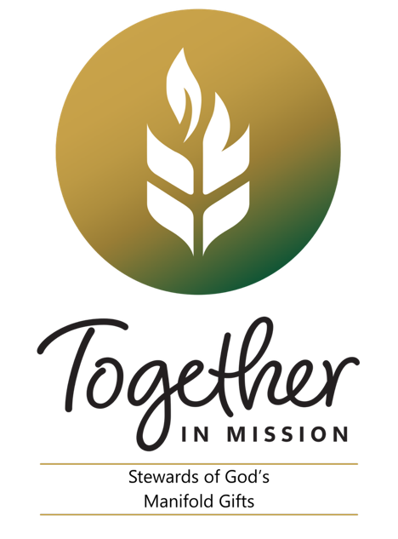
Twenty-seventh Sunday in Ordinary Time
Weekend of October 3/4, 2026
This weekend’s Gospel reading poses some challenging
stewardship questions, particularly at a time when so
many people are becoming disengaged from their faith
communities. When Christ returns, will we be found
working diligently in the Lord’s “vineyard;” converting our
own hearts into a rich harvest of love and compassion?
Calling those outside our vineyard to enter into the joy of the
Lord? Or will we just be living off of what the Lord has given
us, but not sharing God’s love with others? Jesus’ parable
suggests that if we aren’t good stewards of the gifts we’ve
been given, then the gifts will be taken away, and we will be
called to give an account for our failures. We have all we
need for a bountiful harvest, even during these disquieting
times. What will our Lord find when He returns and asks us
to give an account?

Twenty-eighth Sunday in Ordinary Time
Weekend of October 10/11, 2026
There are a number of Bible verses Christians have
memorized. One of them is in Saint Paul’s letter to the
Philippians found in this weekend’s second reading: “I can
do all things through Christ who strengthens me” (Phi. 4:13).
Most people define themselves either by their problems or
their possibilities. Fearful people wake up each morning
ensnared by their problems. Christian stewards wake up
reflecting on their possibilities with confidence and hope.
Some stewardship reflection questions for the week: What
challenges do you back away from because you doubt that
you are up to them? What would you attempt tomorrow if
you were sure God would help you?

Twenty-Ninth Sunday in Ordinary Time
Weekend of October 17/18, 2026
Jesus offers us a profound teaching on stewardship in
this weekend’s reading: What belongs to Caesar? What
belongs to God? Christian stewards recognize that
everything they have belongs to God. God created them,
and God has claims on every part of their existence.
They also realize that the sovereign is an institution
whose nature and purpose is to promote the common
good and protect the welfare of its citizenry. As long as
it accomplishes this mission while treating every single
person with deep respect, justice and compassion, it
merits the steward’s support and cooperation. Christian
stewards know what belongs to the Lord, and they are
better citizens when they live their lives according to his
Gospel.

Thirtieth Sunday in Ordinary Time
Weekend of October 24/25, 2023
There is one command that summarizes this weekend’s
Gospel: to love. For Jesus there is no distinction between
these two commands of loving God and neighbour. One
naturally flows from the other. In fact, for Jesus, these
commands constitute a way of life for Christian stewards; a
unique approach to life and to their relationship with others.
Our neighbors include everyone with whom we come into
contact: family members, friends, people we don’t like,
strangers and particularly those most in need of our love
and compassion. Love calls us to open our hearts and do
more to help others grow closer to the Lord. How might we
follow Christ’s love command more fervently?

Thirty-First Sunday in Ordinary Time
Weekend of October 31/November 1, 2026
In today’s Gospel Jesus lays judgment on the scribes and
Pharisees for the hypocritical way they lived out their faith.
The criticisms he levies are all about the ways righteousness
turns into self-righteousness, and how religious belief
could turn into something that was more about elevating
themselves than about what they could do for God or
their neighbour. Good stewards know that discipleship
means finding ways to serve and searching for ways to
live as a servant of Christ. When faith is
authentically lived out in community everyone is enriched,
and God is glorified. Reflect this week on how you live out
your faith.

