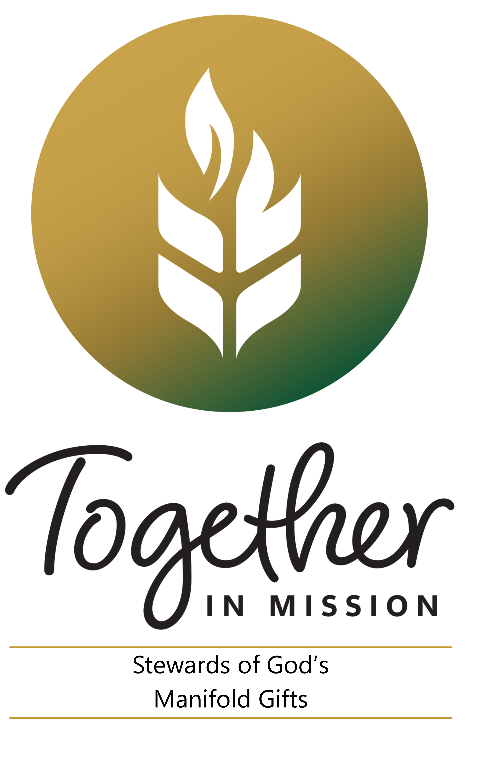
Eighteenth Sunday in Ordinary Time
Weekend of August 1/2, 2026
In today’s Gospel we find an equation the disciples of Jesus
couldn’t solve: Five loaves and two fish divided by 5,000+ people.
They failed to recognize Jesus in the equation;
that whatever they had to offer, Jesus could take it and
bless it and satisfy the hunger of the crowd with it. Good
stewards recognize that the Lord can work miracles with
the gifts they offer to a hungry and broken world. How
often are we willing to offer our gifts in faith, even during
disquieting times, even as insignificant as we think they
are, and count on the Lord to do the rest? How often do we
count Christ into the equation?

Nineteenth Sunday in Ordinary Time
Weekend of August 8/9, 2026
Today’s Gospel reveals what miraculous things can happen
when one embraces a single-minded faith in Jesus Christ.
Peter gets out of a wind-tossed boat when the Lord calls
him. His faith is tested by his obedience to Jesus who is
calling him out onto the water. In the midst of the waves
and the wind, Peter gets out of the boat and walks toward
Jesus. Good stewards heed Christ’s call to them. Sometimes
that call directs them to take on seemingly impossible
challenges. This week, reflect on how the Lord could be
calling you out of the safety of your own “boat” to take on
the impossible.

Twentieth Sunday in Ordinary Time
Weekend of August 15/16, 2026
In today’s first reading, the Lord speaks through the
prophet Isaiah during a time of political upheaval and
moral decline. The prophet had warned of God’s judgment
against people for the feelings of self-importance they
found in their possessions, and condemned them for
various forms of economic injustice such as exploiting the
poor and immigrants. Good stewards know that Isaiah’s
message is as compelling today as it was in the time of the
kingdom of Judah: Do the right thing. Offer justice and
compassion toward others. Be honest in all your dealings.
And remember to observe the day of the Lord.

Twenty-First Sunday in Ordinary Time
Weekend of August 22/23, 2026
Saint Paul reminds us in today’s second reading that the
ultimate origin of everything is God. Since everything
comes from God, we are God’s own. We can never put
God in our debt. There is absolutely no negotiating with
God. Every breath we take is a gift. Every good deed we
perform is grace.
Good stewards realize they are created and called
to make the beauty, greatness, compassion and justice
of God and his gifts known throughout the world. The
stewardship question for us is whether we are willing to
embrace this call, acknowledge our dependence on God
and give our lives over to him completely for this purpose.

Twenty-Second Sunday in Ordinary Time
Weekend of August 29/30, 2026
In today’s Gospel reading, Jesus brings up the topic of
the cross to his followers. They would not realize the
cross was part of God’s plan and was to be their legacy
until after the Resurrection. Today’s followers of Christ
recognize they are stewards of his entire legacy, including
his cross; that through their mutual sacrifices God’s glory is
revealed. They don’t live their lives in Christ only when it is
convenient for them. They make a decision to take up their
cross and carry it, no matter what the cost. In the midst of
the uncertain times we live in, what crosses do we bear in
order to reveal God’s glory?

Twenty-Third Sunday in Ordinary Time
September 5/6, 2026
In today’s Gospel, Jesus speaks to his disciples about the
importance of reconciliation. He emphasizes that healing broken
and wounded relationships lies at the heart of our lives as
his disciples and as stewards of the greatest gift he has given us
—the privilege of sharing in his Kingdom.
Our daily call to stewardship invites us to be ever mindful
of the need to seek reconciliation and to find new ways of
making things right with those around us, so that our lives
may always reflect the Kingdom of God to which we belong.

Twenty-Fourth Sunday in Ordinary Time
September 12/13, 206
In today’s first reading, St. Paul reminds the Romans that, as Christians, they no longer live for themselves but for the Lord. In doing so, he reminds them that they are stewards of all that God has entrusted to them, called to live—and ultimately die—in Christ.
Stewardship reminds us that we are all entrusted with the many gifts God has in store for us. These gifts are given so that we may live lives filled with grace, sharing His love and faithfully carrying out all that He calls us to do.

